Assignment Title

Pedro Xavier Leite Cavadas, Nº Mec. 85090

Information Visualization, Master Degree in Software Engineering, University of Aveiro, 2019

Abstract

This report aims at showing what was done for the project of developing a information visualization application for the information visualization course.

This project consisted of doing an application that was capable of displaying information from a given dataset in a meaningful way and that the user could user a set of questions with that.

# Motivation and objectives

The main motivation of this project was a set of datasets that lacked a visual representation of those same datasets. The main motivation behind the chosen dataset is the fact that it’s highly related to the course since it’s the results of a questionary about information visualization field.

The main objective is to create one visual representation of a dataset (part of it) that is capable of answering some questions that were considered important and useful for some specific users.

# Users and the Questions

The questions that are intended to be answered fall into three main subjects, and are all about the field of information visualization itself:

* Understand the role one may have working in that field;
* Understand the salary one may receive working in that field;
* Understand the tools one may get to use working in that field.

Taking this into acount, people interested in working in the field of information visualization, as well as, professor who teach courses related to this field, are both users that can benefiate from using the application developed for this project.

## Characterization of the users and their context

Taking a deeper look into the two main users of this application, we can describe them as follow:

* Professor – this user will use the application mainly to figure out what types of tools are being used in the modern days to display information in the best way possible;
* Interested to work in the field – this user will use the application mainly to understand if it’ll enjoy working in the field or not, as well as, the types of salaries that it will most likely be paid. However, this user can also use the application to understand which tools it may need to learn to work in the field.

## Questions to Answer

The questions that the application aims at answering are the following, divided by subject:

1. Understand the role:
   1. Most active roles in the field;
   2. Were they hired to do data visualization?
   3. Does the amount of data visualization corresponds to the expectations?
2. Understand the salary:
   1. Salary distribution
   2. Salary distribution by role
   3. Salary distribution by experience
   4. Salary distribution by educational background
3. Understand the tools:
   1. Which are the most used tools in the field?
   2. Which are the most used charts in the field?

# Dataset

The dataset used are the results of a questionary about data visualization done in 2019. This questionary allows to answer a lot of questions about the field and, more specifically, how it is to work in it.

However, even though a lot of questions can be answered the applications focus only on answering the aforementioned ones. This is accomplished using a set of visualization techniques that will be discussed later in this report.

# Visualization Solution

In order to answer the questions with a data visualization application, a set of visualization techniques were used. This techniques are:

* Stacked Bar Chart – used to display the salary distributions by role, experience or educational background;
* Bar Chart – used to display information about the salary distribution;
* Pie Chart – used to display information about the roles, as well as, the tools used in the field.

With the intent of understanding if this techniques worked well for the desired goal, the project was done in a set of iterations (3 to be more precise), with more and more detailed, as well as, improved prototypes, starting with one with a very low fidelity. Between each iteration user feedback was received.

## Low fidelity prototype and user feedback

The first prototype was then a very low fidelity one whose sole purpose was to understand if the proposed techinques did even make sense to use. This prototype was done using *paint* and then feedback was received.

The feedback received here was very positive and everything seemed to make sense, with only a small tip, which was about using brushing when slices of the pie chart were selected in order to update related data.

1. Aspect of the low fidelity prototype

## Functional prototype

The second prototype was already functional and also submitted to feedback.

The feedback received in this prototype was also very positive, with only a few adjustments recommended.

After that, a final prototype was created and it looks as follows:

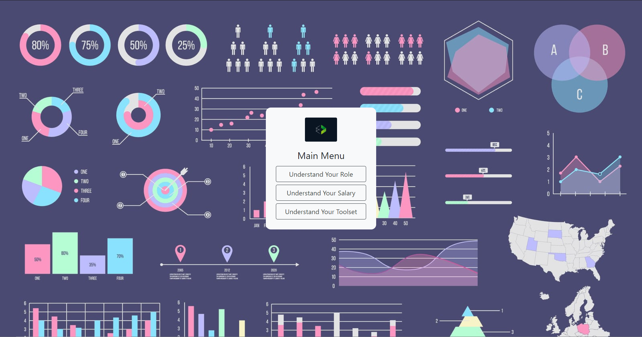

1. Application’s main meny.

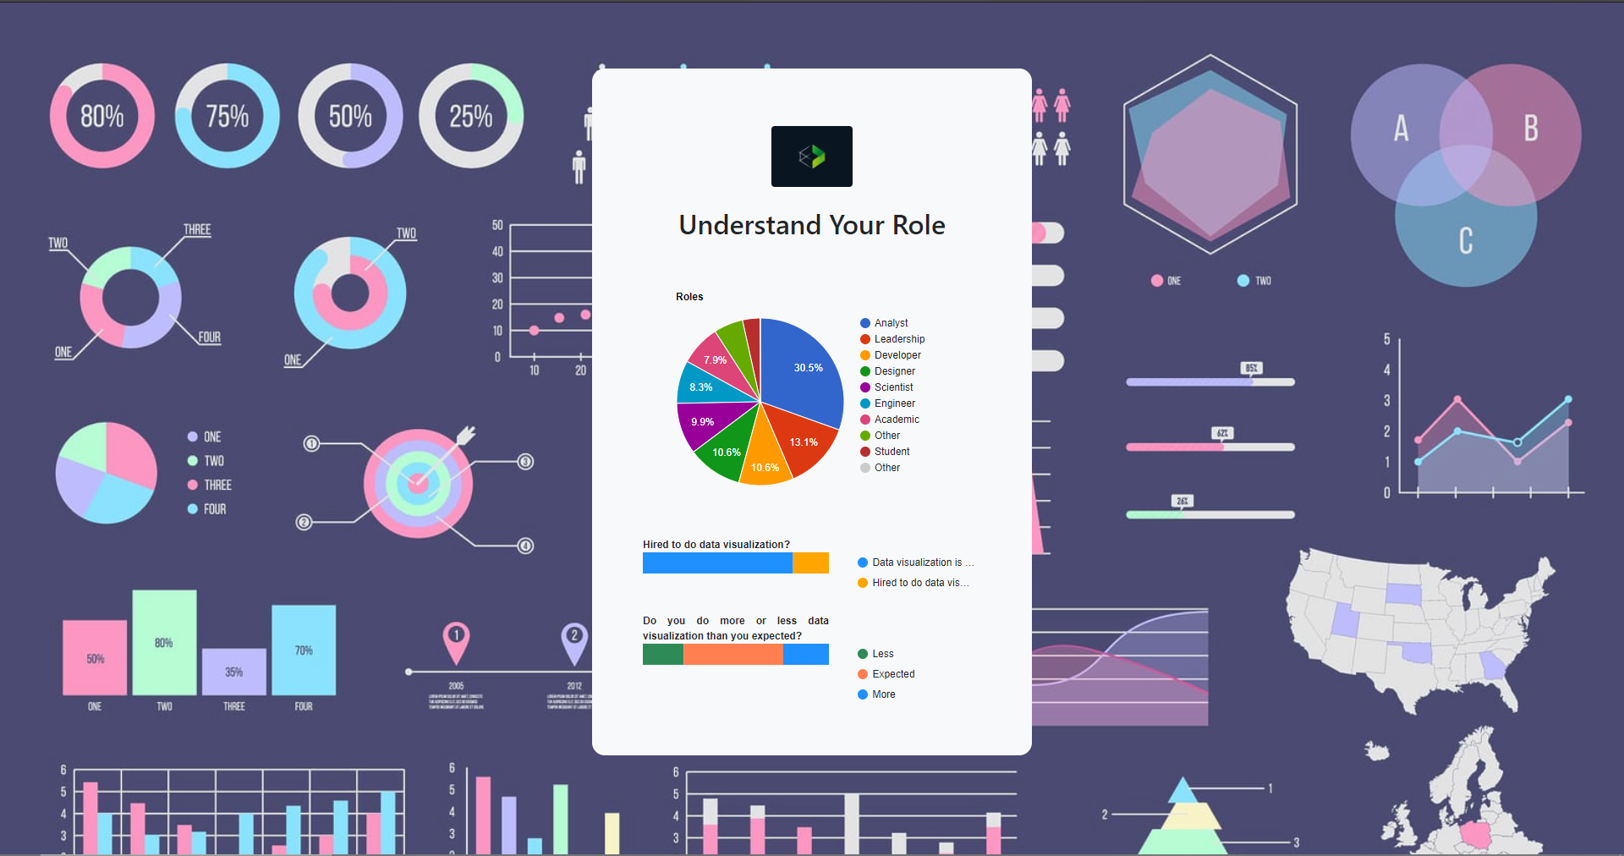

1. Page that answers to the “Understand the role” subject.

1. Page that answers to the “Understand the salary” subject.

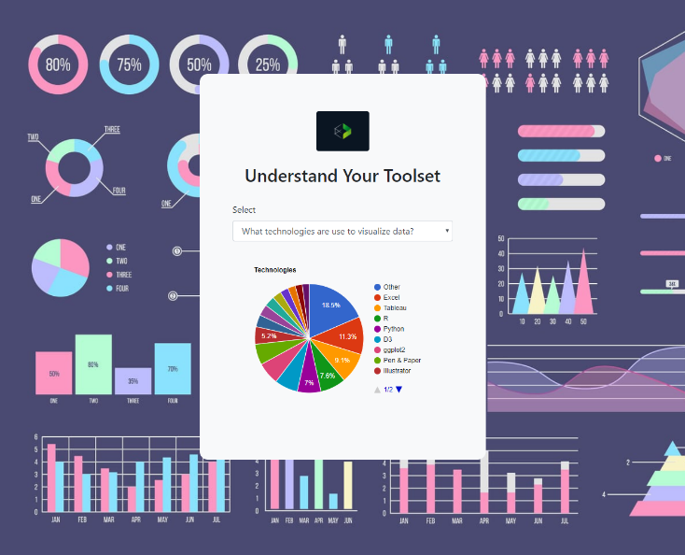

1. Page that answers to the “Understand the tools” subject.

As it’s visible, the application has quite a simple layout and appearence. However, it’s fully capable of answering the proposed questions and therefore achieves the setted goals.

## Implementation challenges

For the implementation of this (web) application d3.js and google charts were used. Google charts were used to do the pie charts and was quite a simple process.

On the other hand, the d3.js was used to do the bar charts and the stacked bar charts, and this was already a bit more complicated, but still relatively simple to do.

The most complicated implementation process was the pre-processment of the dataset which required a lot of work, but, again, still simple to understand how it is done.

## Evaluation and changes in the prototype

Like it has already been said, the feedback was quite positive in all iterations, with the two main changes compared to the prototypes being:

* The addition of brushing when the roles pie chart was selected in order to understand the expectations vs. reality for a particular role;
* Change the used colors to try to not prejudice people with vision problems.

# Conclusion and Future Work

The main conclusions to be taken from this project is that all the goals were achieved, the feedback did help to improve the application, even if it was in general positive, but it also helped to be sure that what was being done was good work.

For future work, it might be interesting to extend the application to answer to even more questions from the dataset, since it has a lot of informationn that can be taken from there and that remained unused in this project.

References

1. [D3.js Tutorial: Building Interactive Bar Charts with JavaScript](https://blog.risingstack.com/d3-js-tutorial-bar-charts-with-javascript/)
2. [Stacked bar chart with tooltips](http://bl.ocks.org/mstanaland/6100713)
3. [Visualization: Pie Chart](https://developers.google.com/chart/interactive/docs/gallery/piechart)